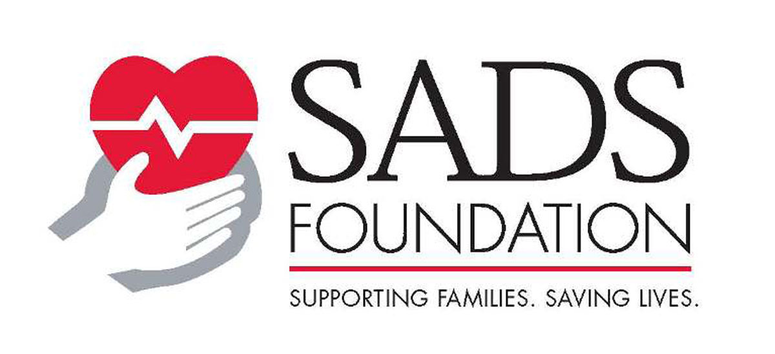
When a Family Member Dies Suddenly
Information and resources for families and professionals

The tragic loss of a child or family member is devastating and leaves the family shocked and overwhelmed. Families who experience the sudden, unexplained death of someone often are left with questions about their other children and family members. “Are they at risk? Should I get them tested? For what? and how should I do that?” Many conditions that can cause the sudden, unexplained death of a child are inherited.
You should make a very careful and detailed family medical history that would include details of anyone who has died before the age of 40. A family history of an unexplained drowning or an unexplained motor vehicle accident should be viewed as suspicious for the presence of a possible heart condition. The Risk Assessment form and/or the Family Pedigree materials are useful tools if you don’t have access to a Genetic Counselor to help you do this (available at www.StopSADS.org).

How Do I Find Out Why My Loved One Died?

- The surviving first-degree relatives (parents, siblings, offspring) of the sudden death victim must have at least a screening 12-lead electrocardiogram (ECG) and a treadmill stress test. Call SADS if you need help with this or a physician referral- seeing a cardiologist or electrophysiologist who is familiar with SADS conditions is important.

- If the autopsy findings are normal or inconclusive: e.g., a “mild myocarditis” or a “slight cardiomyopathy”, ask the coroner/medical examiner to test for SADS conditions such as Long QT syndrome, CPVT, or Brugada Syndrome. Information about genetic testing is on our website (www.sads.org under Genetic Testing). However, most Medical Examiner programs don’t have the funds to pay for genetic testing and most insurance companies do not currently cover this “molecular autopsy”.

- If the coroner or medical examiner can’t test for SADS conditions, ask for blood and/or tissue to be saved using the following procedures:

Blood should be collected in plastic EDTA (purple top) tubes and frozen at -80 degrees C immediately after collection (or no more than 5 days after collection). At least two lavender top tubes (EDTA) each containing 5– 10 ml of whole blood should be collected.

If tissue is saved, cardiac tissue is usually preferred. This should also be frozen at -80 degrees C immediately after collection.

For both sources of DNA, standard freezers are OK if -80 degree C freezers are not available.

Also, if commercial genetic testing cannot be pursued, contacts us at SADS to see if there are any research laboratories providing postmortem genetic testing.

Cardiac disorders (such as the Long QT Syndrome) should be suspected when:
1. The sudden death occurs in a young, seemingly healthy individual and no physical cause can be found for the death.
- The individual seemed essentially healthy in life and the autopsy findings are normal or not conclusive: e.g., a mild myocarditis or a slight cardiomyopathy.
- The events surrounding the sudden death are unusual–for example, the drowning of an experienced swimmer, or a one-person car accident in the middle of the day.
- The individual had a history of syncope or seizure-like activity. (Please note, however, that approximately 30% of those who suffer a fatal cardiac arrest from LQTS had never experienced any symptoms before their first event of sudden death and therefore, their absence does not rule out LQTS.)

Testing Other Family Members
If the family history (above) creates suspicion for a cardiac cause of the death, and or the coroner’s report reveals no known cause of death—parents and siblings of the decedent should be screened by an expert physician with:
- an electrocardiogram (ECG) for long QT syndrome, short QT syndrome, and Brugada syndrome
- a treadmill stress test for catecholaminergic polymorphic ventricular tachycardia (CPVT)
- and an echocardiogram for a heart muscle disease (cardiomyopathy) like hypertrophic cardiomyopathy. However, if the decedent’s autopsy reveals a structurally normal heart, a screening echocardiogram is probably not necessary.

Sometimes a treadmill stress test and/or a Holter or event monitor are helpful and there are some other tests that can be done if indicated. You should discuss this with your physician.

The SADS Foundation Can Help You With Other Questions Including:

* Physician Referral. SADS can provide you with a list of knowledgeable physicians across the country.
* Insurance Issues. SADS can provide you with sample letters and strategies to deal with insurance issues including denials and appeals.
* Identifying Extended Family Members At Risk. SADS can assist you in mapping out your family pedigree to identify family members who might be at risk for heart arrhythmias and need testing.
* Support and Networking. SADS can put you in contact with individuals and families who have had similar experiences. SADS can also put in contact with a local support group or help you start one in your area.

For more information, please contact the SADS Foundation at www.StopSADS.org, email us at sads@sads.org or call 1-801-272-3023.

